Nombre__________________________ **Introducción**

Frases útiles en español:

*Useful phrases in Spanish*

Español Inglés *(English)*

|  |  |
| --- | --- |
| Por favor | *Please* |
| Gracias | *Thank you.* |
| De nada | *You’re welcome.* |
| ¿Cómo se dice ________ en español? | *How do you say ______in Spanish?* |
| No sé. | *I don’t know.* |
| ¿Puedo ir al baño? | *Can I go to the bathroom?* |
| Necesito… | *I need…* |
| papel | *paper* |
| un bolígrafo | *a pen* |
| un lápiz | *a pencil* |
| Saquen… | *Take out…* |
| la tarea | *the homework* |
| los apuntes | *the notes* |
| Pásame los papeles. | *Pass me the papers.* |
| levántate | *Stand up/ get up.* |
| siéntate | *Sit down.* |
| Cierren los cuadernos. | *Close your notebooks.* |
| traducir a ingles/ a español | *Translate to English/ to Spanish* |
| repitan | *Repeat* |
| vale | *Okay* |
| sí | *Yes* |
| no | *No* |
| y | *And* |

Spanish Speaking Countries

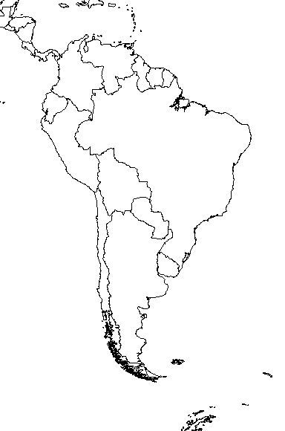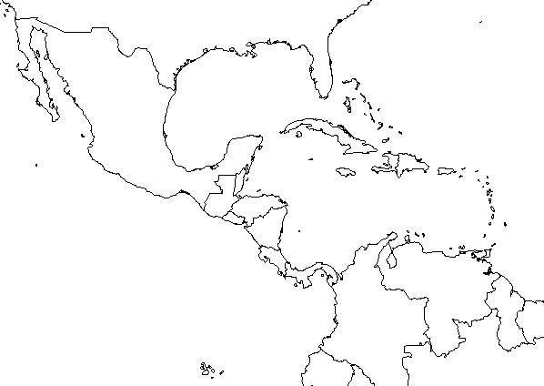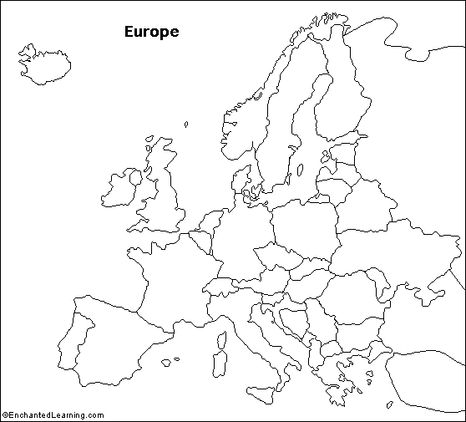

13

Spain

14

Mexico

1

2

3

15

16

17

18

19

20

**Europe**

1. España (Spain)

**North America**

2. México

**Central America**   
3. Guatemala   
4. Honduras   
5. El Salvador   
6. Nicaragua

7. Costa Rica

8. Panamá

**Carribean**   
9. Cuba   
10. la República Dominicana (Dominican Republic)  
11. Puerto Rico   
  
**South America**   
12. Venezuela   
 13. Colombia   
 14. Ecuador   
 15. Perú   
16. Bolivia  
17. Paraguay

18. Chile   
19. Argentina   
20. Uruguay

4

5

6

7

8

9

10

12

11



|  |  |  |
| --- | --- | --- |
| **Letter:** | **What it sounds like:** | Special features of pronunciation:   1. The letter **“g”** sometimes sounds like an **“h”** like in “how” (when it comes before “e/i”). 2. The letter **“j”** sounds like an **“h”** like in “how” 3. The **“ll”** sounds like **“y”** like in “yes”. 4. The letter **“h”** is never pronounced. 5. The letter **“ñ”** sounds like **“ny”** like in “canyon”. 6. In Spain the letter **“z”** sometimes sounds like **“th”** , and sometimes like **“s”**. 7. The letters **“rr”**  sounds like a lot of r’s   (it’s trilled). |
| **A** | *ah* |
| **B** | *bay* |
| **C** | *say* |
| **D** | *day* |
| **E** | *a* |
| **F** | *efay* |
| **G** | *hay* |
| **H** | *achay* |
| **I** | *ee* |
| **J** | *hota* |
| **K** | *ka* |
| **L** | *elay* |
| **M** | *emay* |
| **N** | *enay* |
| **Ñ** | *enye* |
| **O** | *o* |
| **P** | *pay* |
| **Q** | *coo* |
| **R** | *eray* |
| **S** | *essay* |
| **T** | *tay* |
| **U** | *ooo* |
| **V** | *vay* |
| **W** | *dobla vay* |
| **X** | *equees* |
| **Y** | *egriega* |
| **Z** | *zeta* |

Punctuation Marks

In Spanish, ___*exclamation points* and *question marks* always appear at both the beginning and end of sentences.

For example:

**¡**Qué calor hace**!** = It’s hot**!**

**¿**Tienes hambre**?** = Are you hungry**?**

**¿**Cómo estás**?** = How are you**?**

Cognates : *Words that look similar in Spanish and English and mean the same thing.*

*Examples:*

Chocolate = chocolate

Arte = art

Música = music

Tradición = tradition